1. SYSTEM AND APPLICATIONS DEFINITIONS

Cerberus manages Systems and Applications. A system is composed of various applications. You can select your **System** using the drop-down list on the top right corner

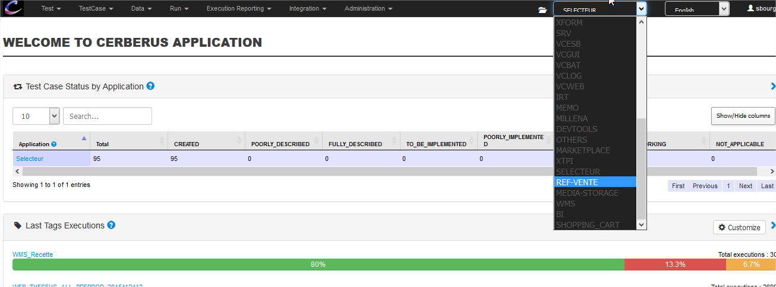

Then, you can figure out **applications** composing your system using the menu ‘Integration > Application’

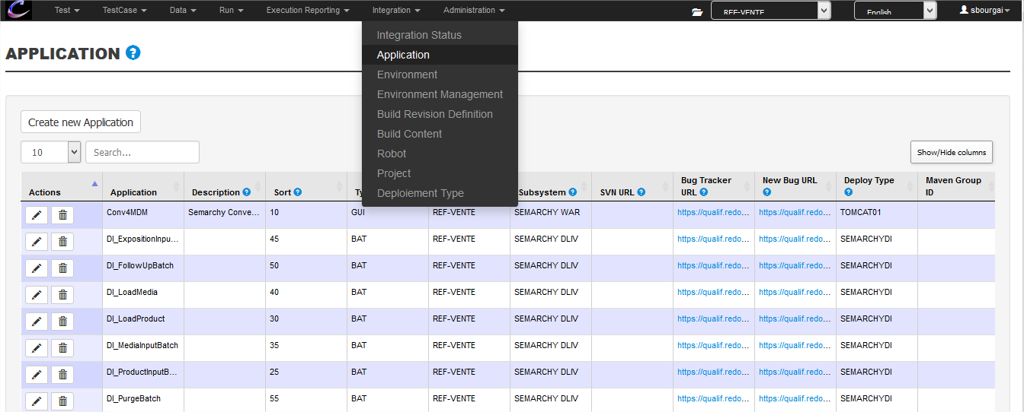

1. MANAGE VERSIONS

Cerberus does not manage application versions. It only manages system versions. You can manage system versions in two steps :

* Define the version of your system
* Set which level of your applications is composing your system version
  1. Define the version of your System

You can define the version of your system using the menu “INTEGRATION >> BUILD REVISION DEFINITION”

Every commits of your applications will pop here. If you have a non-commitable application, you can create a version of this application using the “create new build content” button

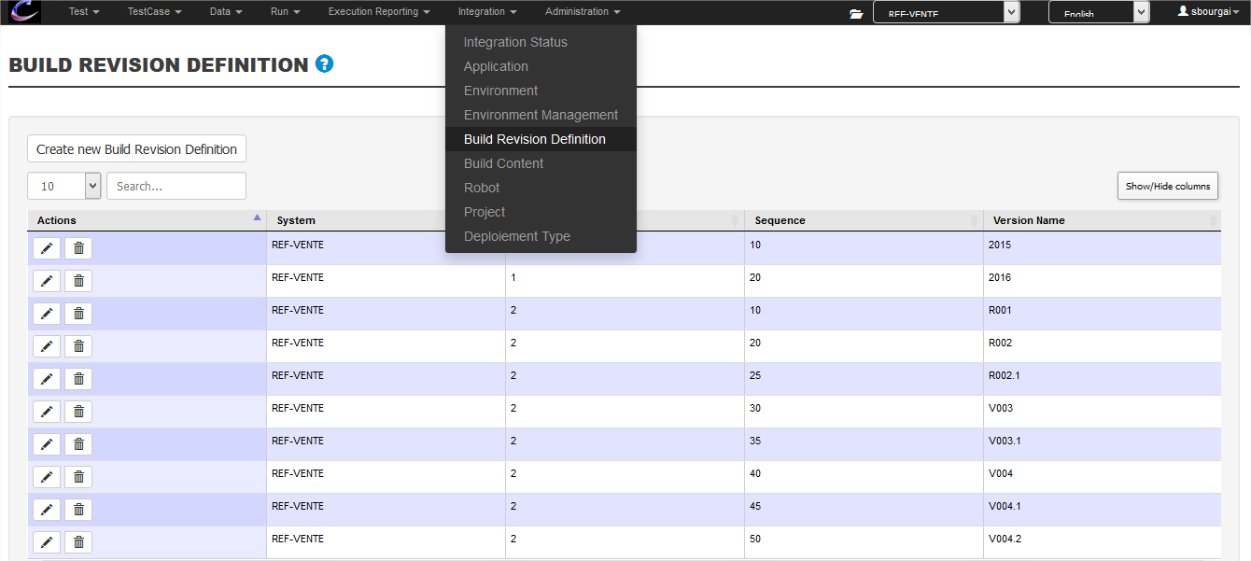

There is no restriction for “Version Name”. This version is defined with following various “levels”. Levels are ordered using “sequence”

Ex :

* **Level 1**, sequence 10 => 2015
  + **Level 2**, sequence 10 => R001
  + **Level 2**, sequence 20 => R002
  + **Level 2**, sequence 25 => R002.1
  + **Level 2**, sequence 30 => V003
* **Level 1**, sequence 20 => 2016

So a version of you system is identified this way :

* **<level 1>**.**<level 2>**
* Ex: My system version is **2015**.**V003**
  1. Set which level of your applications is composing your system version

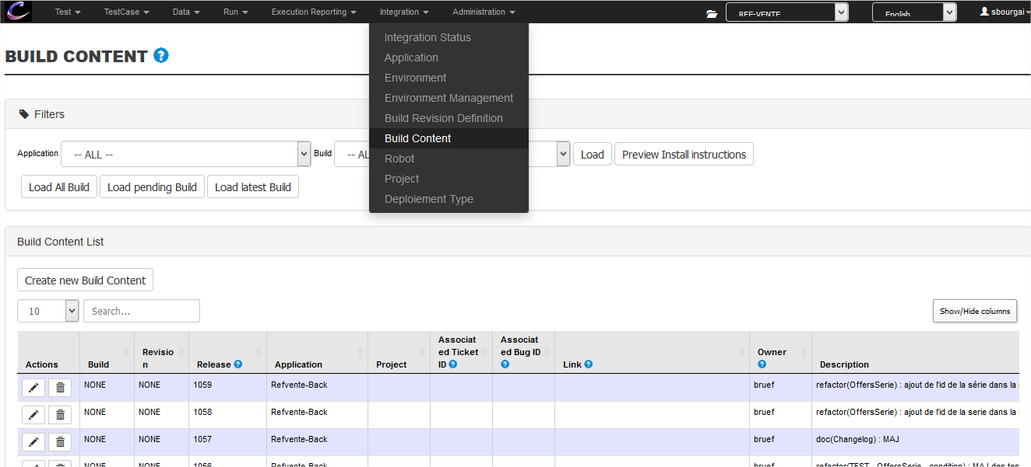

**Level 1** of your system is known as **Build**

**Level 2** of your system is known as **Revision**

**TIP:** the maven version kown by the developer is shown on the very right column

Here, the DI_LoadProduct will be included in the version 2015.V004.2 of the system

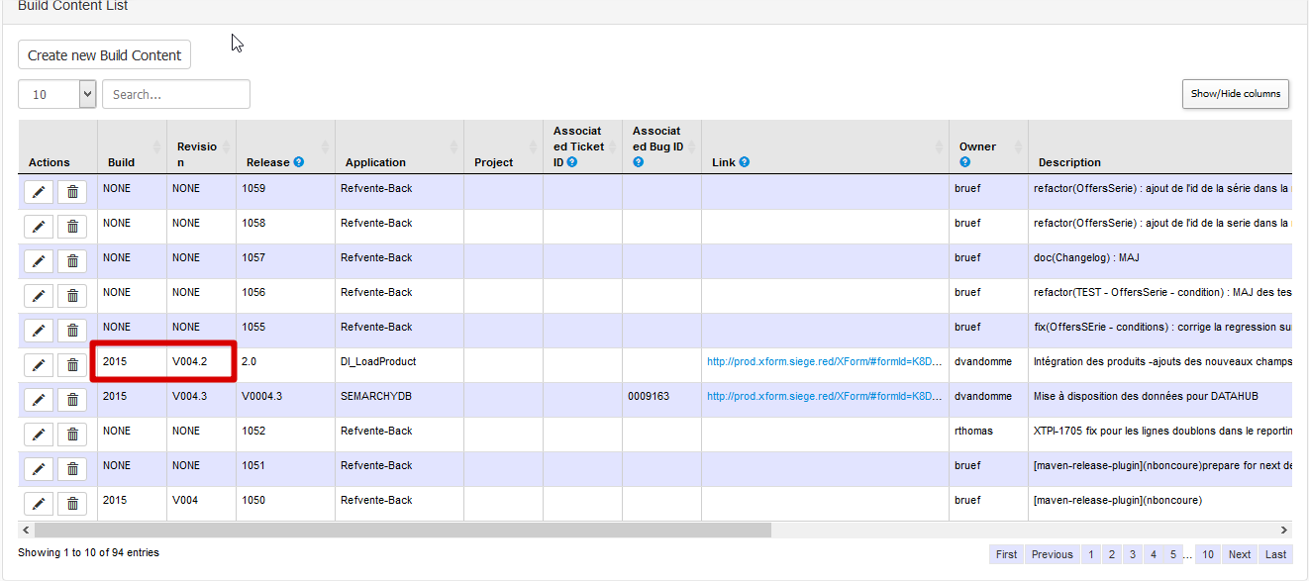

For every application you can set which the Build and Revision of the sytem it is a part of.

Finally, you can figure out what is included in a build,revision of your system clicking on the “preview install instructions” button

